**MOBILE AND E- MONEY**

**EXECUTIVE SUMMARY**

Mobile payments refer to payment processes performed via mobile devices. In this report, we focus our discussion on two mobile payments technologies that are most commonly used in China: near-field communication (NFC) and QR code.

Mobile payments have the highest market share in China compared to its global counterparts and the market will continue to grow in tandem with the popularity of retail e-commerce—likely even faster. China’s mobile payments transaction value is estimated to reach ¥12.2 trillion (US$1.83 trillion) in 2016, up from ¥0.2 trillion (US$31.7 million) in 2012, according to iResearch, a Chinese Internet data provider. The high adoption rate of mobile payments in China is mainly attributable to:

* The ubiquity of mobile Internet,
* Evolving consumer preferences, and
* Advanced infrastructure.

China’s third-party mobile payment industry is highly concentrated, with Alipay and Tenpay comprising 90% of the market in the first quarter of 2016. Traditional payment networks such as MasterCard and UnionPay are actively participating in mobile payments to avoid being disintermediated.

Mobile payments have become an extremely useful tool for retailers to optimize their strategy for the Chinese market. Mobile payments have evolved from being a simple transaction utility to a means of increasing sales, leveraging data, enhancing customer engagement and brand marketing.

In determining the feasibility of mobile payment alternatives, retailers should examine the different systems’ technology, fee structure and user base, among other factors.  
 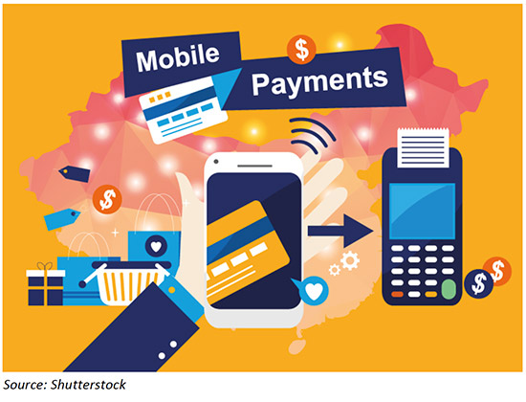

**INTRODUCING MOBILE PAYMENTS**

Mobile payments are typically defined as payment processes performed via mobile devices; these payments eliminate the need for physical credit card payment infrastructure. In this report, we focus on the two mobile payment technologies that are most commonly used in China: near-field communication (NFC) and QR code. We note that there is some overlap, as certain popular payment methods use both technologies.

Popular payment services that rely on NFC technology include PayPal, Apple Pay, Huawei Pay and Samsung Pay. QR-based payment services include WeChat Pay, Alipay and Baidu Wallet, while their NFC technology is not widely adopted. To pay for an item that has a QR code, the customer scans a bar code that contains information—such as a webpage with product or order information provided by the vendor—and is then redirected to a payment page in his or her smartphone’s browser to complete the transaction.

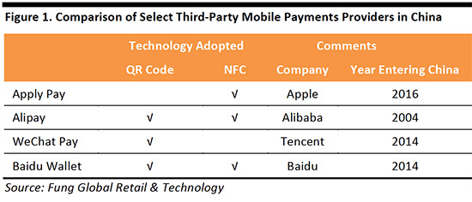

**DEFINING E-WALLETS**

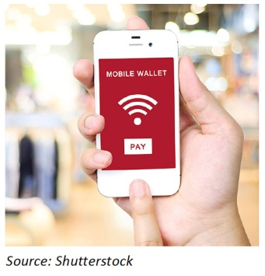E-wallets (also known as mobile wallets or digital wallets) are used to initiate mobile payments, and may be supported by either NFC or QR technology. An e-wallet enables users to store their credit card information, such as number, and expiration date, in a mobile app instead of on a plastic card with a chip or magnetic stripe. Users can then make purchases through the app. E-wallets are considered more convenient, as they provide a better user interface and can store coupons and loyalty card information.

**MOBILE PAYMENT INCREASINGLY IMPORTANT FOR RETAILERS IN CHINA**

Mobile payments have become increasingly popular in many European countries, as we discussed in our July 2016 report [*Mobile Payments: Supporting Europe’s Move to a Cashless Society*.](https://www.fungglobalretailtech.com/research/mobile-payments-supporting-europes-move-cashless-society/) We initially explored the Chinese mobile payment industry in our September 2015 report [*The Changing Face of Mobile Payments*](https://www.fbicgroup.com/sites/default/files/Quick%20Take%20on%20Mobile%20Payment%20by%20FBIC%20Global%20Retail%20Tech%20Sept%2017%202015.pdf). In this report, we provide an overview of the Chinese mobile payment ecosystem, with a focus on:

1. The latest industry dynamics
2. Key players and business models, supplemented by case studies
3. Challenges and future opportunities
4. Practical advice for international retailers that are preparing to enter the Chinese mobile payments market

As mobile payments move from being merely another means of payment to a tool for increasing customer loyalty and brand marketing, those retailers that provide mobile payment options will be more relevant to customers. In China, e-wallets’ share of the mobile payment market is the highest globally, although other developed markets have higher penetration levels for both mobile subscriptions and Internet usage. In China, it is crucial for merchants to optimize the mobile payment experience in order to reach a critical mass of domestic shoppers.

**CHINA’S MOBILE PAYMENT MARKET SIZE**

China’s mobile payment market is the largest in the world in terms of absolute size and growth potential. According to iResearch, a Chinese Internet data provider, the Chinese mobile payment market is estimated to reach ¥12.2 trillion (US$1.83 trillion) in 2016, up from ¥0.2 trillion (US$31.7 million) in 2012.

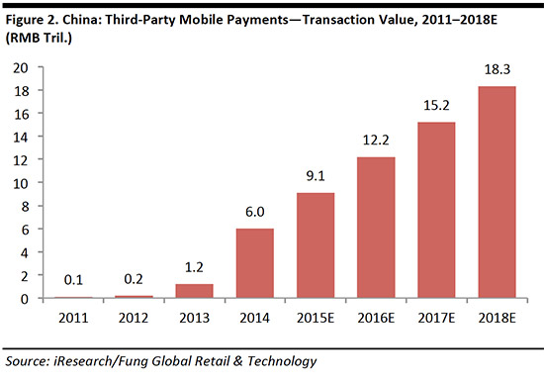

The third-party mobile payment market in China is concentrated, with the two largest players—Alipay (owned by Alibaba) and Tenpay (owned by Tencent) accounting for a combined 90% share.

**DRIVERS OF MOBILE PAYMENT ADOPTION IN CHINA**

E-wallets account for 58% of the mobile payment market in China, which is the highest percentage globally. In the US, e-wallets account for just 15% of the market and in the UK, they account for 23%, according to Worldpay’s*Global Payment Report*. The high rate of mobile payment transactions in China is mainly due to a confluence of three factors, which will continue to drive the trend going forward:

1. Ubiquity of mobile Internet
2. Evolving consumer preferences
3. Advanced infrastructure and widespread merchant adoption

***Ubiquity of Mobile Internet***

Chinese Internet users typically use their mobile phones to surf the web, which we think provides fertile ground for mobile payment adoption and explains why e-wallets account for such a high share of mobile payments in China. China’s mobile Internet users totaled 620 million in 2015, representing 90% of the country’s total Internet users and more than double the number from just five years earlier, according to China Internet Network Information Center.

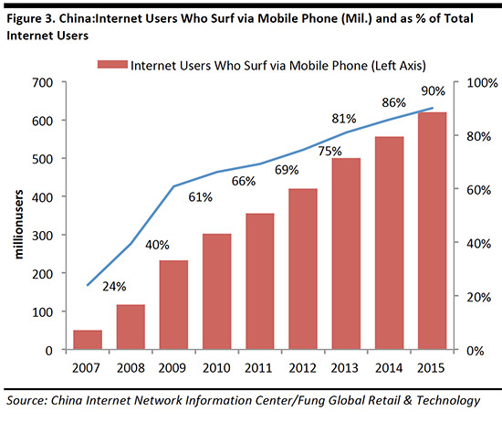

We believe that rising mobile subscription and Internet penetration in China, coupled with Chinese consumers’ propensity to shop on their mobile devices, is conducive to higher adoption of e-wallets. Mobile subscription and Internet penetration have increased rapidly in China in the last decade. Between 2004 and 2014, the mobile subscription rate in China rose from 26 per 100 people to 92 per 100 people, according to the World Bank. By comparison, the mobile-subscription-per-capita rate is 0.98 in the US and 1.25 in the UK; the world average is 0.97.

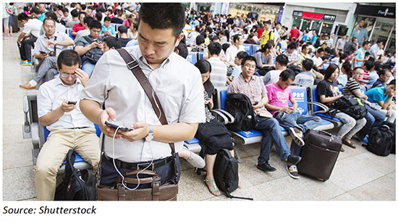

Similarly, Internet penetration in China almost doubled between 2004 and 2014: in 2004, only 25.6 out of every 100 people had access to the Internet in China, but by 2014, the figure was 49.3 out of every 100. The Internet penetration rate is 87.4% in the US and 91.6% in the UK, while the world average is 40.7%. So, despite rapid increases in mobile subscriptions and Internet penetration in China, we see further room for growth in both metrics, as the country’s rates remain below those of its global peers.

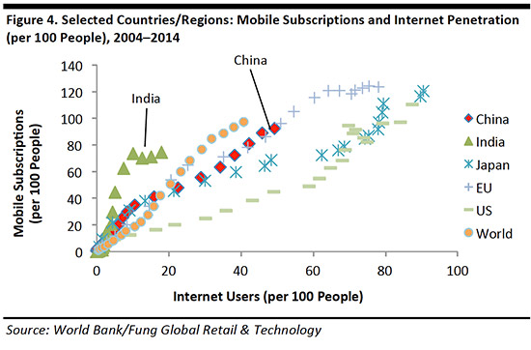

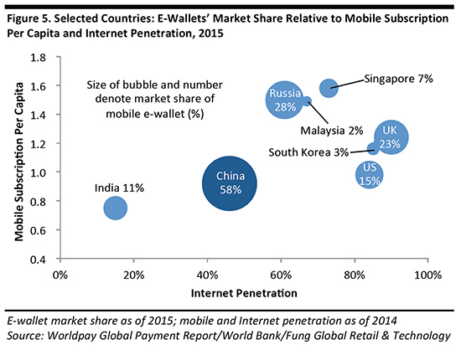

***Evolving Consumer Preferences***

Mobile subscriptions and Internet penetration alone do not explain e-wallets’ disproportionately high share of mobile payments in China; customer adoption of e-wallets is also critical. E-commerce is increasingly integrated into the daily lives of Chinese consumers, and online-to-offline and omni-channel retailing solutions are increasingly popular, making mobile payment the transaction method of choice for many shoppers.

China has the highest incidence of smartphone shopping as a percent of all online shopping in the world, with 68% of those surveyed by PayPal (2014) having purchased via a smartphone in the past 12 months.

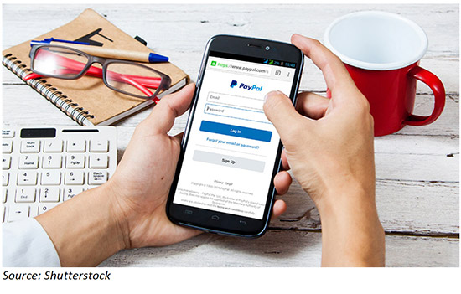

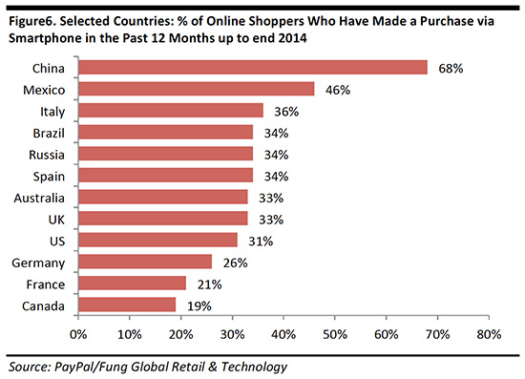

PayPal found that growth in mobile commerce and online commerce are correlated. In fact, mobile commerce growth is expected to exceed that of online commerce across the countries in PayPal’s sample.

China is expected to exhibit strong growth: between 2013 and 2016, mobile commerce is expected to grow at a 52% CAGR and online commerce at a 23% CAGR in the country, according to PayPal.

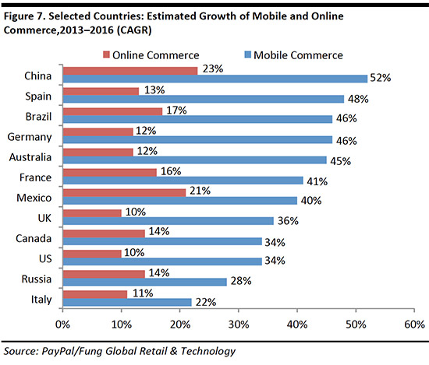

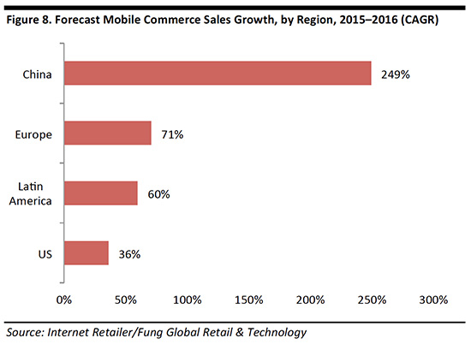

E-commerce represented 16.4% of China’s total retail sales in the first half of 2016, the highest rate globally, according to Euromonitor International. In other major markets, such as the US and the UK, e-commerce accounts for 14%–18% of all retail sales.

Euromonitor expects China’s e-commerce as percentage of all retail sales to rise to 21.7% in 2020.

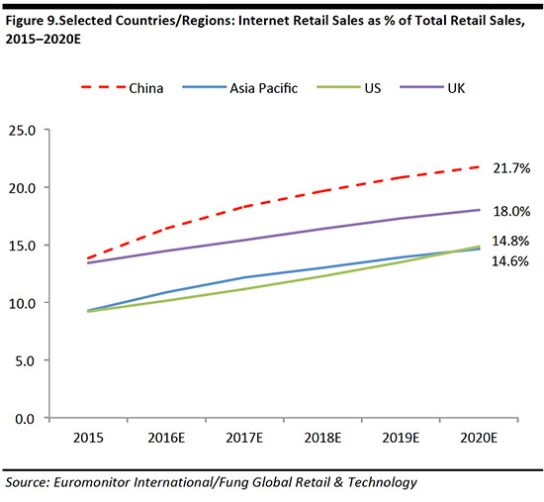

***Advanced Infrastructure and Widespread Merchant Adoption***

Mobile payments entered the Chinese market as a more convenient alternative to credit card payments, and their rapid growth is due in part to the country’s weak credit card culture and the wide acceptance of mobile payment technologies by merchants. According to China’s central bank, credit card penetration in the country fell to 0.29 per person at the end of 2015 from 0.34 at the end of 2014.

***Mastercard Mobile Payments Readiness Index***

The MasterCard Mobile Payments Readiness Index, which measures markets in terms of their preparedness for and receptivity to mobile payments, ranked China 10th globally, and 4th in Asia, behind Singapore (1st), South Korea (4th) and Japan (6th). This was largely due to China’s strong mobile payment infrastructure—as the mobile phone industry and NFC terminalization in China are relatively sophisticated—and its high level of consumer readiness: Chinese consumers are familiar with and willing to use different types of mobile payments.

**KEY PLAYERS IN CHINA’S MOBILE PAYMENTS INDUSTRY**

The third-party mobile payment industry is concentrated in China. As of the first quarter of 2016, Alipay and Tenpay held a combined market share of 90%.

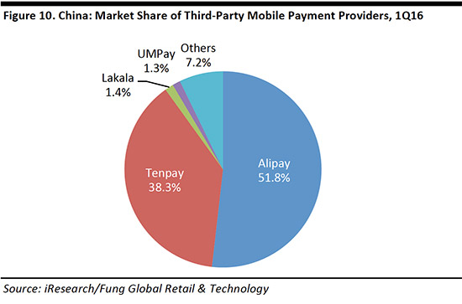

***Key Third-Party Mobile Payment Providers in China***

In this section, we highlight the most popular mobile payment methods in China, where the mobile payment ecosystem is dominated by Internet and e-commerce companies Alibaba and Tencent. By contrast, in the US, the key players are payment and technology companies: PayPal, Apple and Google. Major players in China’s mobile payment industry include:

* **Apple Pay:** an NFC-based mobile payment system developed by Apple that allows people to use their mobile devices to buy goods and services. Users’ accounts are linked to their credit and debit cards, and personal data are encrypted by tokenization technology. Apple Pay was rolled out in China in February 2016.

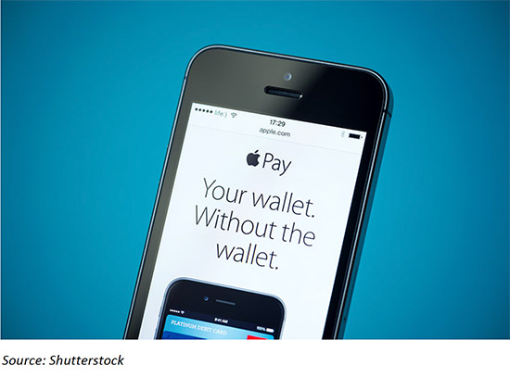

* **Alipay:** a QR code payment method that is used on the Taobao and Tmall websites, the most popular online marketplaces in China. Alipay was launched by Alibaba Group in 2004 and has the largest market share in China.
* **WeChat Pay:**launched by Tencent in 2014, this system relies on QR-code technology, and has been widely adopted in China. Tencent also owns the QQ Wallet and Tenpay systems, but we focus on WeChat Pay here because it has been more widely adopted than the other two services.
* **Baidu Wallet:**this QR code payment system launched by Baidu in 2014. The service is positioned as the wallet for users of Baidu, the most popular search engine in China. Baidu Wallet users are offered discounts for Baidu’s other services, such as music.

**CASE STUDY: THE DIGITIZATION OF TRADITION—VIRTUAL RED ENVELOPES AS AN EFFECTIVE USER-ACQUISITION TOOL**

The virtual red envelope is an example of how China’s tech companies took advantage of a cultural tradition to further entrench their presence in the mobile payment industry.

**The Challenge**

Tech companies often face the challenge of gaining traction with users and merchants simultaneously. They need to incentivize users to bind their payment credentials to their accounts, and at the same time, convince merchants to devote resources to building their platform.

**WeChat’s Solution**

WeChat launched a peer-to-peer payment feature called Red Envelopes prior to Chinese New Year in 2014. Giving out red envelopes with cash to relatives and friends is a time-honored tradition during Chinese New Year. WeChat deftly used this tradition to get users to adopt mobile payments on its messaging platform.

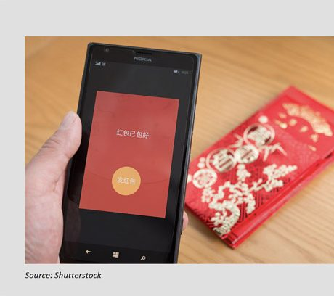

The results have been staggering. In 2016 (the third year since launch), WeChat delivered 8.08 billion digital red envelopes on Chinese New Year’s Eve (10.6 red envelopes per user). The number of red envelops that were shared, which has developed into a popular peer-to-peer transfer method from merely a Chinese New Year tradition, grew from 1 billion for the full year of 2015, up from 16 million in 2014. WeChat has enjoyed some significant benefits by launching its virtual red envelope feature:

* **Unlocking of subsequent transaction activity across WeChat ecosystem:**A prerequisite for successful expansion into mobile finance is winning over Chinese users’ digital wallets. As users top up their WeChat accounts to give away red envelopes, they bind their credit card to their accounts, and open themselves up to other payment services on WeChat’s one-stop platform.
* **Gamification of Chinese New Year:**WeChat users can allocate a sum of money to be distributed among a specified group of friends on a “first come, first served” basis. This feature has proven very popular, as users like to compete to get the most red envelopes; the thrill of competition leads to more and more envelopes being sent.

**Reaction from Competitors**

WeChat is by far the most popular platform for exchanging virtual red envelopes, but some competitors have introduced their own version of virtual red envelopes in order to increase the profile of their mobile payment platforms. In 2016, Alipay saw 324.5 billion red envelopes exchanged and Baidu Wallet saw 11.2 billion red envelops being exchanged, which contained a total of ¥300 million (about US$45.6 million) between January 28 and February 8.

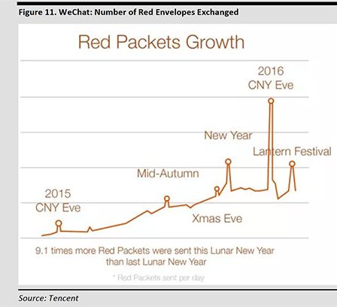

***Participation of Traditional Payment Networks into Mobile Payments in China***

As Alipay, WeChat Pay and Apple Pay become increasingly popular in China, traditional payment networks are actively participating in mobile payments to avoid being disintermediated. For example, UnionPay has introduced QuickPass, MasterCard has introduced MasterPass and Visa has introduced Checkout. QuickPass is a contactless payment service that allows users of NFC-enabled smartphones to make payments by waving their devices at UnionPay point-of-sale (POS) terminals. The service was launched in China by state-backed UnionPay in 2015.

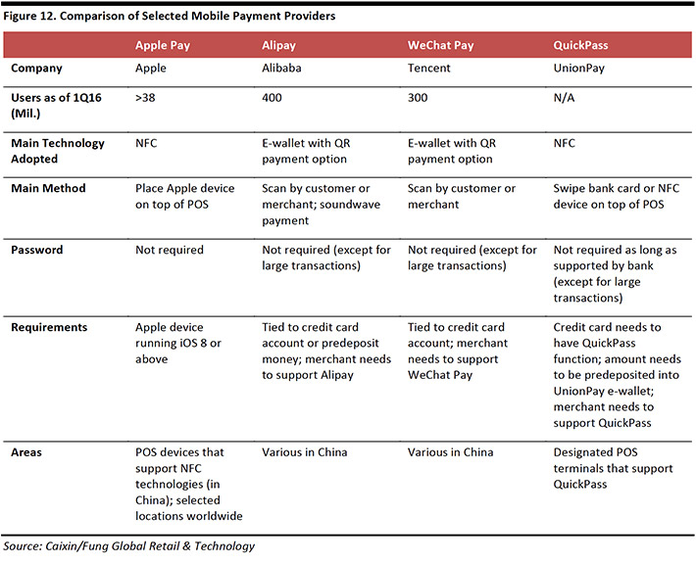

**KEY CHALLENGES AND OPPORTUNITIES FOR MOBILE PAYMENTS IN CHINA**

***Will NFC or QR Technology Prevail?***

China’s mobile payment industry faces two sources of potential friction as it develops: regulation and security. Given the competing technological standards of NFC and QR, the Chinese government’s regulations are critical. The NFC system is gaining prominence, as Apple, Huawei and Samsung have partnered with UnionPay in China. At the same time, e-wallets such as Alipay and WeChat Wallet utilize QR code payment technology, which many consumers are already familiar with and which is well suited to the current infrastructure in China. We do not expect either system to dominate, but instead to coexist.

**CASE STUDY: APPLE PAY FOR NFC**

Since its official launch in China in February 2016, Apple Pay has become the new face of NFC payments in the country. The initial response was remarkable: more than 3 million cards were activated on Apple Pay in the first two days it was available.

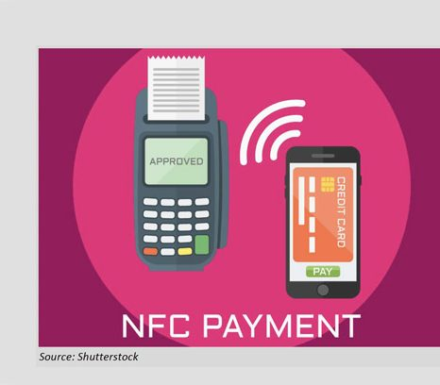

China’s regulators hold great power in deciding the fate of international technology companies, as was evidenced by Uber’s experience in the country. Uber faced regulatory challenges and eventually sold its Chinese operations to Didi Chuxing. Google and Facebook have both faced censorship in China. However, Apple Pay has partnered with state-backed UnionPay, so we do not expect the service to experience any regulatory difficulties.

***Regulation: What Does the Future Hold for Third-Party QR Mobile  
Payments in China?***

QR code payments have raised security concerns in China, and the government’s policy stance on the technology standard is still unclear. Payment by QR code can expose users to fraud because it takes place in an unsecure environment on the Internet. Viruses embedded in the code can capture personal information and hackers may be able to break into mobile devices to steal account information. Transactions made through QR code systems are also difficult to track because there is inadequate verification of a user’s identity to guard against fraud.

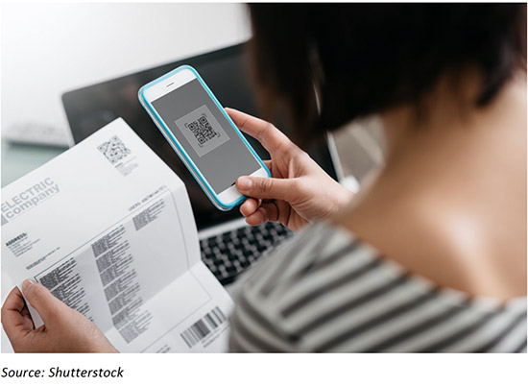

Considering the inherent security risks, China’s regulators banned the use of QR code technology for third-party mobile payments in 2014, stalling the release of virtual credit cards (originally scheduled for the second quarter of 2014) and the use of QR code payments by Alibaba and Tencent.

Though banned officially by the government, QR code payment has nonetheless been widely adopted by consumers and merchants. QR code payment standards, which are drafted by the Payment & Clearing Association of China and authorized by the People’s Bank of China, show the government’s determination in standardizing such payments.

We expect that the draft guidelines will likely offer more clarity on QR code payments, and set the scene for further growth of the technology.

***Where Are We Headed? Identifying Future Growth Opportunity in the Chinese Mobile Payment Market***

iResearch data indicate that China’s third-party mobile payment transaction value reached ¥6.2 trillion (US$942 million) in the first quarter of 2016 and that it will reach ¥18.3 trillion (around US$2.8 trillion) by 2018. China’s mobile payment transactions in the first quarter grew by 33% quarter over quarter and by 202% year over year.

China’s demographic shift to a two-speed economy—characterized by an increase in the number of affluent households, a new generation of sophisticated consumers and increased e-commerce—will likely drive incremental consumption growth and, hence, mobile payment growth.

According to iResearch, Chinese consumers choose to pay by mobile payments most frequently for:

* Online shopping (mobile payments are used for 94% of all transactions)
* Recharging prepaid cards (93%)
* Payment transfer (92%)
* Travel (83%)

We see the most scope for growth in transaction categories that currently account for the lowest share of mobile payments:

* Cross-border transfer (mobile payments are used for only 41% of all transactions)
* Insurance purchase (48%)
* Financial analysis (49%)

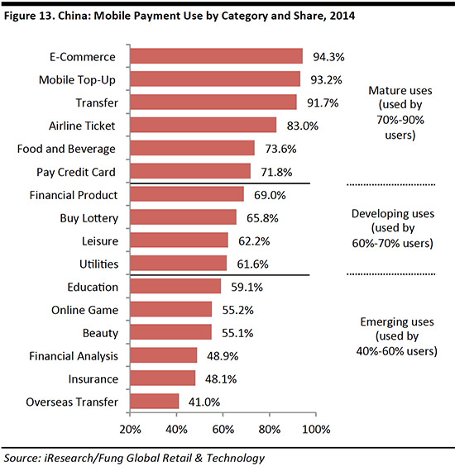

**IMPLICATIONS: WHAT DOES THIS MEAN FOR RETAILERS TARGETING CHINESE CONSUMERS?**

Mobile payments have become an extremely useful tool for retailers to optimize their strategy for the Chinese market. But as technology advances, how customers interact with and pay merchants will continue to evolve. Merchants have long regarded mobile payments as a simple transaction utility. Their attitude has now changed, and they are seeing mobile payments as a means of increasing sales, leveraging data and enhancing customer engagement.

A 2015 survey on digital commerce by PwC found that mobile payment providers need to focus on four extra factors in order to capture the opportunities:

* Improving customer engagement and loyalty: use marketing, such as customer loyalty programs and personalized offers, to drive higher sales
* Developing better understanding of customer data: use data analysis to gain better insight into customer spending behavior, which can then be used to optimize inventory management
* Integrating data among channels more effectively
* Ensuring high levels of security



These four factors are increasingly intertwined with online-to-offline models. Sesame Credit and Yu’eBao, both from Alibaba’s Ant Financial division, are examples of value-added services developed by payment providers to enhance the customer experience. **Sesame Credit**leverages big data technology to calculate individuals’ credit scores based on factors such as past financial information. The system is expected to simplify the loan extension procedure and will be mandatory beginning in 2020. **Yu’eBao** offers money market funds to its investors with substantially higher interest rates than banks. The funds are mostly short-term loans from the highest-rated institutions, to minimize risk.

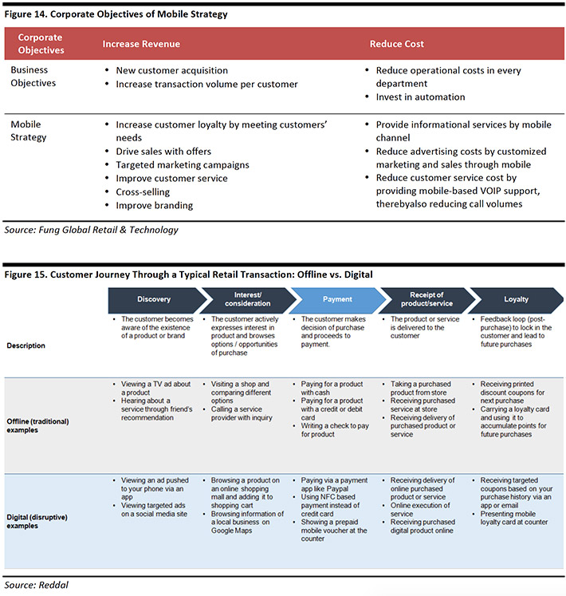

***Which Mobile Payment Solution Should Retailers Choose?***

NFC-based and QR code payment methods are the most viable options for retailers and will likely be embraced by consumers. In our view, retailers should consider the following factors when deciding which mobile payment method to adopt:

* Is the method platform dependent? China’s smartphone sales are increasingly skewed toward Android, which may imply bias for platform-agnostic mobile payment methods over Apple Pay. According to Kantar WorldpanelComTech, iPhone sales accounted for only 18% of total smartphone sales in China during the second quarter of 2016.
* What are the fees levied by different mobile payment methods? Third-party mobile payments typically bypass settlement by the acquiring bank. Consequently, retailers are likely to enjoy lower transaction fees with these methods.
* Does the method have a vast user base? Alipay and WeChat Pay, as affiliates of China’s e-commerce giants, have inherited a large number of users from the cross-selling of services, which is a positive for retailers. Alipay is the payment method for Alibaba’s Tmall and Taobao websites and, so, has gained significant customer traction. Similarly, users of WeChat, China’s most popular social app, have been encouraged to bind their credit cards to their accounts.

The security of e-wallets is improving as technologies advance and as regulations are put in place, thus reducing the threat for retailers.

**CONLCUSION**

In China, mobile payments have a higher market share than they do in any other country, and the market will continue to grow in tandem with the popularity of retail e-commerce—likely even faster.

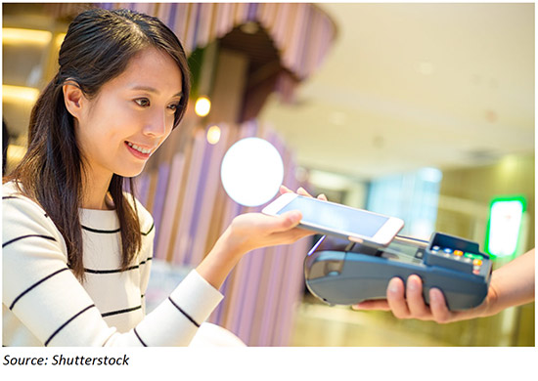

ELECTRONIC MONEY

NFC-based and QR code mobile payments are most commonly used by Chinese consumers, and we expect new government regulations will offer more clarity to the outlook of the mobile payment environment in China.

Retailers in China will need to optimize their mobile payment strategy and leverage mobile payments to increase sales and customer loyalty. In determining the feasibility of mobile payment alternatives, retailers should examine the different systems’ technology, fee structure and user base, among other factors.

Mobile pay is taking [China](https://www.cnbc.com/china/) by storm and changing daily commerce.

The transformation of a society limited to bills denominated in 100 yuan ($15) or less into one where QR payment codes abound was by far the biggest change in mainland China since my last visit four years ago.

When eating out or shopping with local friends, they paid by scanning a QR code on the restaurant table or by showing a similar code on their smartphones to the store clerk. A spices shop, museum souvenir store and seller of traditional Chinese calligraphy brushes all had signs saying they accepted mobile pay.

Rather than, "Do you take credit cards?" the question was often "Do you take Alipay? WeChat Pay?" The running joke was that street beggars would rather take a mobile donation than cash.

Lack of red tape and a less developed financial system have apparently allowed mainland China to leapfrog the developed world into embracing mobile payments.

Mobile payment volume in the country more than doubled to $5 trillion in 2016, according to Analysys data cited by Hillhouse Capital in a May report. In the first quarter of this year, Alipay had 54 percent of that mobile payments market, and WeChat Pay accounted for 40 percent, the study said.

The Chinese mobile pay habit is also affecting other countries. More than 6 million Chinese traveled abroad during the "Golden Week" national holiday in early October, according to state-backed media outlet Xinhua. That puts pressure on popular tourist destinations like Japan and Hong Kong to add mobile pay services.

Just over the border in Hong Kong, I heard a few mainland Chinese customers asking a store clerk to scan their phones' QR codes while Cantonese-speaking locals paid in cash. In April, Nikkei reported that the [number of stores accepting Alipay in Japan will double to 45,000 this year](https://asia.nikkei.com/Business/AC/Stores-accepting-China-s-Alipay-seen-doubling-in-Japan), according to the regional head of Ant Financial Services.

The growth of mobile pay in China comes off a solid base of smartphone users. The ubiquitous WeChat messaging app from Chinese technology giant [Tencent](https://www.cnbc.com/quotes/?symbol=700-HK) reached 963 million monthly active users in the second quarter. In professional settings, adding each other on WeChat sometimes replaced business card exchanges.

Alipay, which is owned by [Alibaba](https://www.cnbc.com/quotes/?symbol=BABA) affiliate Ant Financial Services, has 520 million users, according to its international website.

The app is linked to online money market fund Yu'e bao, encouraging users to invest and spend with Alipay. Attractive interest rates of nearly 4 percent or more have turned it into the largest money market fund in the world, with 1.43 trillion yuan ($217 billion) as of the end of June, according to state media reports citing Yu'e bao's manager, Tianhong Asset Management.

Hong Kong-based research investment company CLSA expects Chinese electronic payments volume to quadruple to 300 trillion yuan by 2021. During that time, online wealth management products' assets under management should triple to 6.7 trillion yuan and online loans could also triple to 3.5 trillion, said Elinor Leung, head of Asia Telecom and Internet Research at CLSA.

"High mobile internet and ecommerce penetration, and an underdeveloped traditional financial market will drive growth," Leung said in a Sept. 5 report.

Mobile pay is growing so rapidly in mainland China that as a foreigner I sometimes found it difficult to complete basic transactions without it.

When I tried to pay at a Beijing [McDonald's](https://www.cnbc.com/quotes/?symbol=MCD) on a late night, the only payment options were China's Union Pay credit card system, Apple Pay or WeChat Pay and Alipay. As an American visitor without a Chinese bank account, I wasn't able to find a way to use those systems and the store clerk wouldn't take my cash.

"Cash is accepted in all McDonald's restaurants across China. After our investigation, we believe this is an isolated case that happened during night shift change, and thus, all cash counters were temporarily closed," a McDonald's China Customer Care Center told me in an email.

Taxis were also nearly impossible to hail in Beijing due to the rise of Didi, a ride-hailing app that bought Uber's China operations in a deal worth $35 billion last summer. Because Didi was linked through WeChat, I couldn't use it without a Chinese bank account.

When I finally did get a taxi, the driver gave me a fake 50 yuan bill in change. Several stores also claimed three of my 100 yuan bills from a New York money exchange were counterfeit. If I could participate in the cashless society, I would not have lost about $50.

The growth of mobile pay in China has supported another business: bike sharing.

Led by a few start-ups, the number of bikes stacked along the side of the street or sometimes scattered even alongside highways in China has exploded. The number of monthly active users doubled from February to more than 20 million in March, according to TrustData cited by Hillhouse Capital.

Two of the largest Chinese-based start-ups, Ofo and Mobike, say they have a combined more than 13 million bikes around the world and have each raised at least $1 billion.

Incidentally, Mobike entered the U.S. on Sept. 20 by deploying bikes in Washington, D.C., while Ofo made its first foray into the country by launching in Seattle in August.

The dominance of mobile pay also means companies like Ant Financial and Tencent have access to hordes of personal data. That data can then be shared with the Chinese government, which [prioritizes control.](https://www.cnbc.com/2017/09/19/chinas-bitcoin-clampdown-is-likely-here-to-stay-analysts-say.html) Some parts of China have been testing a personal credit score system linked to mobile pay data.

But unless privacy issues have immediate negative consequences, convenience may trump all. A smartphone is increasingly the only thing someone in China needs to carry when going out.

FINTECH

**An introduction to the Who, the Why, and the How of FinTech in China.**



**Let’s start with some recent facts about China:**

* **Large User Base**: There are >3.4bn third-party payment accounts in China. For context, Paypal has 227mn users globally (Dec 2017).
* **Explosive growth**: Total internet loan balance grew more than 36x from 2013–2016; Total Third-Party Payment Value grew 74x from 2010 to 2016.
* **Most innovative globally**: Chinese companies secured 5 of the top 10 slots in the KPMG/H2 ranking of the top fintech firms globally in 2017, absolutely dominating the fintech landscape.
* **Valuations are very high:** The largest Chinese FinTech company, Ant Financial, has been valued at more than $100bn, on par with top-tier financial institutions like Goldman Sachs ($94bn market cap). *[Though comparing private company valuations with public company market capitalizations are imperfect comparisons]*
* **Huge and growing demand for financial services:** In 2017, 4 years after creation, the money-market fund *Yu’E Bao* (the name translates as leftover treasure) by Alibaba, accessed via Alipay, overtook JP Morgan’s US government money market fund to become the world’s biggest money market fund — and growing.
* **Global leader:** China accounts for three-quarters of the global market in online lending. (Brookings Institution)
* **Funding:** VC investments in China Fintech has grown at a compound annual growth rate of 300% from 2014–2017. In 2016, China overtook the USA as the global leader in fintech VC activities, owning 47% of global fintech investments. (KPMG)

***“China’s market is too big, too valuable, and has too much untapped potential for international players to ignore. “***

— The Rise of Fintech in China, A Collaborative Report by DBS Bank and EY, November 2016

**So…**

**How did FinTech get so big in China?**

**What does China Fintech look like?**

**Who are the key players?**

This post aims to provide a simple introduction to these questions.

We will first look at some of the background and drivers of FinTech in China. Then, we will look at some of the key players in China FinTech.

The material is derived from various reports (acknowledged at the end) and also from my personal experience living and working in China from 2014–2016, right during the massive FinTech rise and adoption. Due to the complexity and ever-changing nature of China FinTech, this is meant to be a door-opener to greater discussion and debate, rather than an exhaustive discussion of the various segments.

Here is a graphic overview of China’s FinTech Ecosystem vs US and Japan, markets which we might be more familiar with, to provide some context.

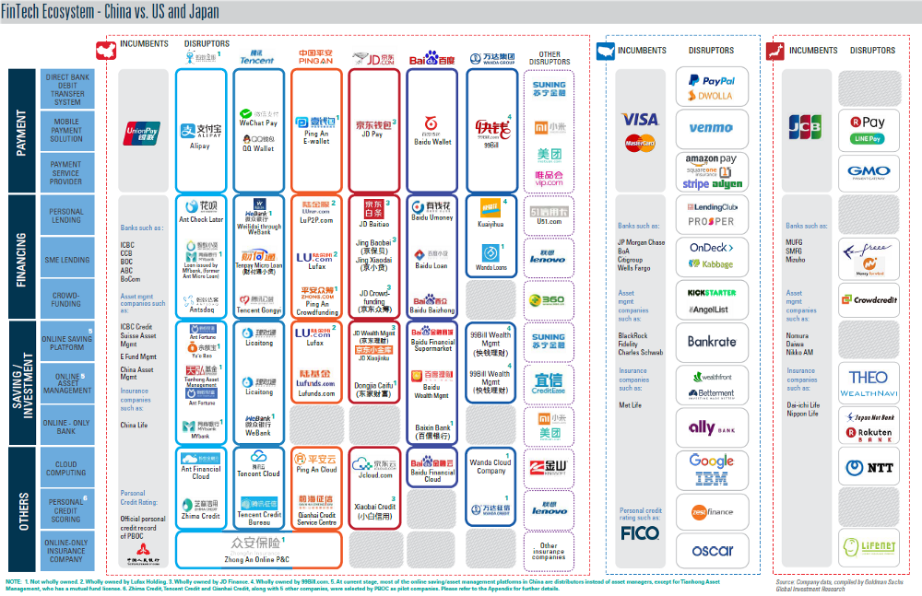

**Comparison of the FinTech Ecosystem in China, USA and Japan**(Source: Goldman Sachs)

**How did FinTech grow so fast and get so big in China?**

We can bucket the reasons into three main parts: Regulation, Infrastructure of financial services, and the Widespread usage of E-commerce and social media. Let’s look deeper into each of these three parts.

**1.** **Regulation**

**At first (2013–2015), regulation of China FinTech players was light-touch, enabling essentially explosive growth:**

* Traditionally, China’s economy has always been centrally-planned, driven by investment and built around large state-owned enterprises (SOE). Naturally, banks and other financial institutions had focused mainly on providing services for these SOEs, underserving SME and retail consumers.
* As we see in the US, sluggishness of incumbents and failure to cater to the changing needs/certain groups of consumers could create space for disruptors to enter — the same essentially happened in China.
* From a macro-economy point of view, China needed to transition from an investment-led economy to a consumption-led one. The government was (and is) highly supportive of innovation and threw their weight behind the the development of inclusive finance to drive consumption.

Hence, arguably, it is often said that the fintech space in China was able to flourish due to “regulatory arbitrage”, unique to the country itself.

**But unregulated growth led to fraud and increased risks events, especially in internet lending:**

* Oliver Wyman cites independent data estimates that as of May 2017, over 60% of the 5,890 online peer-to-peer platforms that ever existed have ceased operations.
* There were some high-profile scandal cases. For example, Ezubao (peer-to-peer lending platform), which raised more than RMB 1.5 billion in 1.5 years, proved to be a Ponzi Scheme, making it the biggest-ever financial fraud case in China.

**Subsequently, regulation began to evolve and became more sophisticated (2016-Present):**

* 2016: Chinese government laid out a comprehensive policy framework for regulating the internet finance industry across all verticals: lending, insurance, crowdfunding, payments, fund distribution, consumer finance.
* Mar 2017: Established centralized clearing house (*Wanglian*) for all third-party payments, enabling regulatory oversight on fund flows, which were previously circumvented by fintech players. What is unique here and very different from most of China’s infrastructure is the involvement of private capital (Ant Financial and Tencent each own 9.61% of Wanglian).
* May 2017: Central bank set up a fintech committee to act as overall coordinator of all fintech efforts and policies.

**2.** **Infrastructure of financial services, the right confluence of several factors**

**China was a late mover in terms of digitization and mobile, but leapfrogged:**

* China was still predominantly cash-based even until the early 2000s.
* In contrast, developed economies like UK, USA, Korea, had mostly already moved from cash to cashless payments (debit cards/credit cards).
* The confluence of various important trends: Internet taking off, birth of e-commerce, smartphones; happened as China moved towards digital payments.
* This allowed Chinese consumers to leapfrog directly from cash to digital payments, skipping cards.

**The next point is subtle, but very important.**

**China had LOW credit card penetration but HIGH debit card penetration:**

* China had low credit card penetration (0.3 credit cards/person) but one of the highest debit card penetration in the world (3.6 credit cards/person).
* Since each digital payment account has to be ultimately linked to a bank card in order to work (Think: your Venmo account), the ready debit card infrastructure enabled rapid fintech expansion.
* In addition, the low penetration of credit cards meant there was a massive, untapped pool of consumers needing credit, paving the way for fintech in the credit space.

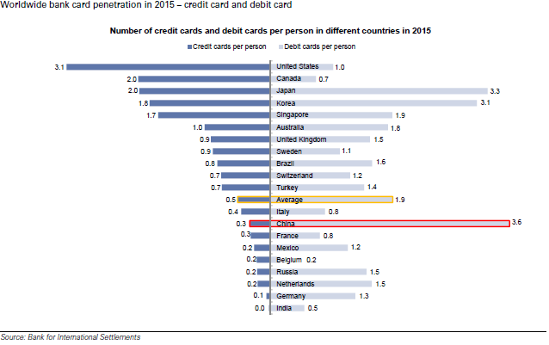

**China has low credit card penetration, but one of the highest debit card penetration.**

**Lack of existing physical payment infrastructure:**

* This is about QR codes. Something which never really took off in the US.
* In part, this was due to Tencent’s aggressive promotion. But the ease of use, low adoption costs and the lack of existing infrastructure (like POS terminals) especially in brick and mortar shops enabled QR codes to take off in a big way in China.
* Basically, using a smartphone, a customer can pay a merchant via their digital wallet simply by scanning the merchant’s QR code which could also be on the merchant’s smartphone, for example.
* As merchants were onboarded rapidly due to low fixed cost of adoption and incentive pricing by Tencent and Alibaba, it became possible to use digital cash in Alipay or Wechat Pay accounts to buy almost anything.
* Living in Shanghai during2014–2016, I witnessed first-hand this transformation in my everyday life. Once, I lost my debit card and didn’t find out until more than a week later — I simply never needed to use it — something still impossible in Philadelphia.

**3.** **Widespread usage of E-commerce and social media, coupled with Internet boom:**

**E-commerce, China Style:**

* Dominant domestic online marketplaces for Chinese consumers such as Taobao (Alibaba), Tmall (Alibaba), JD.com were launched just a few years prior to 2000. The mobile and internet boom drove Chinese consumers to begin shopping online, leapfrogging their under-developed traditional offline retail infrastructure.
* What is crucial to note is that emergence of these e-commerce firms served as a precursor to the rise of the FinTech firms — many of which are their financial subsidiaries focused on payments and third-party remittances.
* Alipay was launched by Alibaba Group, as an internet payment service to their e-commerce platform. A parallel may be drawn to Ebay and Paypal.

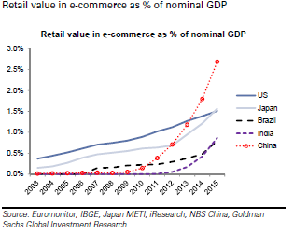

**Proliferation of e-commerce in China is a key growth driver of third-party payment.** (Source: Goldman Sachs)

**Social Interactions and Gamification, China style:**

* WeChat Pay launched in 2013, is owned by Tencent and embedded into its massively popular mobile communication platform, WeChat. Half of WeChat’s 889 million monthly active users spend over an hour on the app every day.
* WeChat Pay has become a model in the “gamification of finance” via their red packets — users can send each other red packets filled with digital cash and games that allow users to compete fastest-fingers-first to “snatch” a red packet released into a group chat. This feature was launched during Chinese New Year in 2014, went viral and enabled WeChat Pay to grow their user base by 1000-fold in 3 years.
* Many observers, myself included, view the ingenuity behind the red packets as pure genius: taking a beloved cultural phenomenon, turning it into a game that builds on and fosters social interactions, driving customer acquisition costs down to zero.

**Who are the key players? And what does China Fintech look like?**

* Alipay and Tenpay own about 84% of the entire third-party payment market in China. Alipay is the largest (51%), Tenpay (33%) as of 2016.
* Here is one way to think about it: It is believed that Alipay handles more B2C/consumption-related payment activities (due to their e-commerce groundings), while Tenpay has a larger share of C2C transfers (due to their social nature).
* In China, due to the “integration” and “ecosystem” mindset of the large players, Payments can be seen as the most important gateway into many other fintech applications, like wealth management, insurance, credit.
* We also take a look at Lufax, the leading lending platform in China.

1. **Alipay (now under Ant Financial)**

Alipay started in 2004, originally as an escrow service provider to Alibaba’s Taobao marketplace.

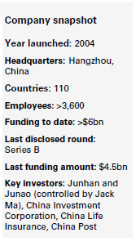

* Alipay allows consumers to verify the receipt and quality of goods before releasing money to sellers, which solved the lack of trust for e-commerce in early stage and helped Alibaba to emerge as China’s leading e-commerce platform.
* Since 2005, Alipay has extended beyond escrow servicing for Alibaba into being a payment method for other functions like online gaming, wealth management, credit, financing.
* When Ant Financial was established in 2014, Alipay moved under them. As of 2016, there were 520mm active annual users of Alipay.
* Key merchants: Taobao, Tmall, Ctrip, Weibo, Didi Chuxing, millions of offline merchants (per People.cn), and millions of SMEs in Alibaba’s ecosystem.

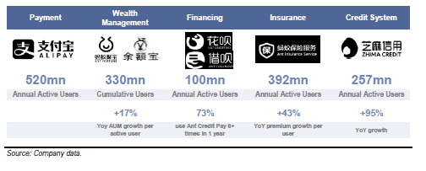

**Ant Financial’s leading breadth and scale**

**2.** **Tenpay (Tencent)**

Payment arm of Tencent, encompasses WeChat Pay (launched in 2013, inside WeChat) and QQ Wallet (inside QQ, also a social chat platform that came about before WeChat). As of 2016, there were 600mn monthly active users.

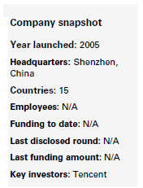

* The launch of WeChat red packets in 2014 and the use of WeChat Pay in the rise of online ride-hailing (Tencent had backed on of the key companies which subsequently merged to form Didi Chuxing) helped Tenpay gain tremendous momentum and market share from Alipay.
* Key merchants: JD, Didi Chuxing, Meituan Dianping, Watsons, 7-Eleven, eLong, and more than 700k offline merchants (per “Cash-Free Day” on Aug 8th, 2016).

**So what does WeChat Pay and Alipay look like?**

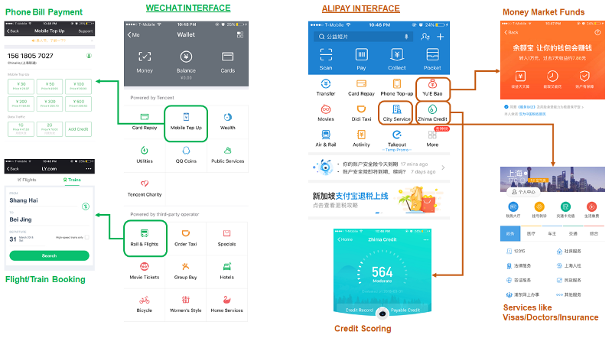

Various functionalities readily available on Wechat Pay and Alipay mobile versions

**3. Lufax (Shanghai Lujiazui International Financial Asset Exchange, Lu.com)**

Founded in September 2011 by Ping An Insurance Group, and started with P2P lending as the only product. It is currently the largest P2P lender and wealth management platform in China with over $24b of loans on its books. Lufax makes money by taking a 4% fee when matching borrowers and investors.

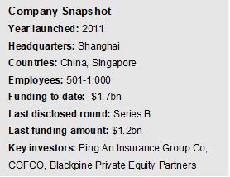

* More than 31 mm registered users
* As a division of Ping An (one of China’s largest insurance companies), Lufax uses Ping An’s balance sheet to guarantee all of its loans, a foundation of trust and security that no other Chinese P2P player can claim. Lufax uses a proprietary risk model to determine a borrower’s risk.
* The company has since branched out of P2P lending, becoming a much broader platform that works together with funds, insurance companies and financial license holders. Currently sells over 4000 products and includes a wealth management business.
* Has aggressive international expansion plans. Singapore is Lufax’s first overseas market with launch of Lu International, Singapore’s first wealth management platform that provides a 100% mobile, facial recognition account opening and investment process.

The speed and unique ways by which China firms has evolved and innovated has captured the imagination of many of us. As we look to the future, there remains several questions. Can the China FinTech story be replicated elsewhere, but tailored to the local context? What will the face of China FinTech look like as the current disruptors move along the maturity curve?What does truly global competition look like, as the likes of Alibaba, Tencent, Baidu compete against Google, Amazon and Facebook?

The next few years will be truly exciting.

LINKS-

<https://www.ipsos.com/sites/default/files/ct/publication/documents/2017-08/Mobile_payments_in_China-2017.pdf>

<https://assets.kpmg.com/content/dam/kpmg/cn/pdf/en/2018/03/2017-fintech-50.pdf>

<https://www.economist.com/news/finance-and-economics/21717393-advanced-technology-backward-banks-and-soaring-wealth-make-china-leader>

<https://www.brookings.edu/blog/order-from-chaos/2018/02/08/whats-happening-with-chinas-fintech-industry/>